**PEN TESTING TEAM – EXPLOITSION:**  
CHRISTABELLE ALVARES

DRISTI DINESH

JAVERIA MALIK

PENETRATION TEST REPORT OF METASPLOITABLE

CSEC 471 | PENETRATION TESTING

CONTENTS

EXECUTIVE SUMMARY OF FINDINGS 3

REMEDIATION REPORT 5

VULNERABILITY ASSESSMENT SUMMARY 7

• Vulnerability Risk Definition and Criteria 7

• Vulnerability Findings 8

• Vulnerability Summary Table 9

RISK ASSESSMENT 10

PENETRATION TESTING PHASES 12

❖ PLANNING PHASE 12

❖ RECONNAISSANCE PHASE 12

❖ SCANNING PHASE 13

DETAILED VULNERABILITY FINDINGS 18

❖ EXPLOITATION PHASE 18

• C1 – Samba Version 3.0 Exploit 18

• C2 – vsftpd 2.3.4 Exploit 23

• C3 – Bind Root Shell on Port 1524 25

• H1 – Private Credentials Visible on Home Page 27

• H2 – OpenSSH 4.7 Exploit 28

• H3 – ProFTPD 1.3.1 Exploit 30

• M1 – Apache Tomcat JSP Engine 1.1 Exploit 31

The Exploitsion team conducted a basic network services penetration test on the target host machine to discover potential vulnerabilities, ascertain the risk of compromise, and provide appropriate remediation steps. A simulated test in a virtual machine environment was conducted in order to exploit the vulnerabilities of Metasploitable, an intentionally vulnerable machine, using Kali Linux.

# EXECUTIVE SUMMARY OF FINDINGS

The preliminary test included an aggressive scan for open ports, which further presented vital information about services running on the target machine and their versions. Using the Metasploit framework console, the team was able to gain local and root access by exploiting various application vulnerabilities present on the target machine. Analysing the impact and likelihood of the risk associated with the exploitation of these vulnerabilities, the overall risk is calculated to be **critical at 95%.**

⊠ Summary of Weaknesses:

1. Port scanning revealed that a number of open ports, which poses a great risk of Denial-of-Service and various other attacks, allowing adversaries to discover the services on the host computer.
2. Multiple applications that perform the same functions as others and are not required are listening on open ports, thereby giving avoidable point of entries to attackers.
3. Vulnerable applications that have not been updated, patched or are of old versions, are running on the host machine. Exploitation of these vulnerabilities will allow attackers to gain access to sensitive information in the system.

⌛ Recommended Remediation:

The suggested steps, if applied in a timely and imperative manner, will lower the risk significantly.

1. Close unnecessarily open ports to avoid attackers exploiting vulnerabilities in the associated services or applications. In other words, employ stricter control over port access.
2. All unnecessary and unutilized applications must be removed immediately.
3. Patches and updates for services and applications must be checked for regularly and implemented imminently.
4. The setup of a firewall with appropriate configurations must be administered in the network.

# REMEDIATION REPORT

After conducting a rigorous penetration test on the Metasploitable virtual machine, it is clear that many significant steps need to be taken to eradicate the numerous risks on the machine. Currently, the services, traffic, and open ports on the machine are easily visible through a simple scan. This allows attackers to easily exploit any vulnerable service running on the machine and gain unauthorized access to data stored in the system. The following are suggestions of major steps that can be taken to recondition the vulnerable state of the machine:

1. Port access must be controlled, thereby preventing discovery of service and application information through port scanning. Implementation of a firewall, in which port access can be controlled either automatically or manually, will be advantageous in this situation. It will also assist in preventing unauthorized access and other malicious activity.
2. Strong passwords must be implemented for all users, especially root and administrator users, to avoid the success of brute-force password cracking attacks.
3. An access control list should be implemented with only necessary rights and privileges to respective users. For instance, a guest user should not be able to remotely upload executable files that could act as backdoors or key loggers.
4. Intrusion Detection and Prevention systems need to be installed so that even if an attacker manages to gain access or tries to send malicious packets, it is immediately detected and prevented without major harmful effects.
5. Event logs should consistently be monitored for any suspicious activity.
6. Regular updates and security audits will need to be performed in order to keep a log of any vulnerable services or applications, and quickly patch those vulnerabilities through updates.

# VULNERABILITY ASSESSMENT SUMMARY

## Vulnerability Risk Definition and Criteria

The risk ratings assigned to each vulnerability are determined by averaging several aspects of the exploit and the environment, including reputation, difficulty, and criticality.

CRITICAL

|  |
| --- |
|  |
|  |
|  |
|  |

**Critical** vulnerabilities pose a total compromise of the target environment and should be fixed immediately.

**High** risk vulnerabilities provide a serious risk to the environment and should be corrected promptly. EDI  
UM

**Medium** severity vulnerabilities represent a moderate risk to the environment.

**Low** severity vulnerabilities provide minimal risk to the target environment. Remediation of low risks is often a lower priority than other.

## **Vulnerability Findings**

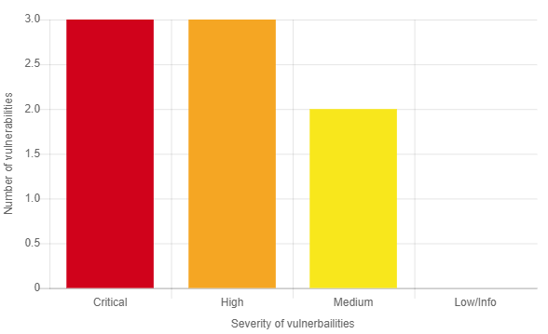

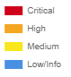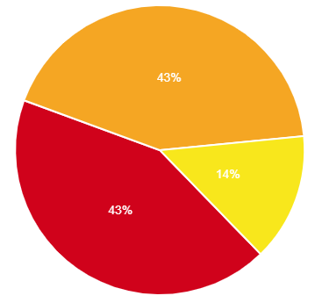

## Vulnerability Summary Table

The following vulnerabilities were determined to be of highest risk, based on several factors including asset criticality, threat likelihood, and vulnerability severity.

|  |  |  |  |  |
| --- | --- | --- | --- | --- |
| **IMPACT RATING** | **CRITICAL** | **HIGH** | **MEDIUM** | **LOW** |
| **VULNERABILITIES** | **3** | **2** | **1** | **0** |
|  |  |  |  |  |

|  |  |
| --- | --- |
| **VULNERABILITY ID – NAME & REMEDIATION** | **IMPACT LEVEL** |
|  |  |
| **C1 – Samba Version 3.0 Exploit**  Install patched newer version of Samba. | **CRITICAL** |
| **C2 – vsftpd 2.3.4 Exploit**  Install patched newer version of vsftpd.  Consider uninstalling either vsftpd or ProFTPD  due to redundancy. | **CRITICAL** |
| **C3 – Bind Root Shell on Port 1524**  Do not bind root shell execution to port connection. | **CRITICAL** |
| **H1 – Private Credentials Visible on Home Page**  Remove local user credentials from webpage, visible  publically. | **HIGH** |
| **H2 – OpenSSH 4.7 Exploit**  Do not make valid credentials visible publically. | **HIGH** |
| **H3 – ProFTPD 1.3.1 Exploit**  Do not make valid credentials visible publically.  Consider uninstalling either vsftpd or ProFTPD  due to redundancy. | **HIGH** |
| **M1 – Apache Tomcat JSP Engine 1.1 Exploit**  Install patched newer version of Apache Tomcat.  Do not use default credentials for login. | **MEDIUM** |

The risk assessment matrix gives an idea about the overall risk by considering the category of probability or likelihood against the category of consequence severity. This simple mechanism increases visibility of risks and assists in management decision making.

# RISK ASSESSMENT

|  |  |  |  |  |  |  |  |  |  |  |
| --- | --- | --- | --- | --- | --- | --- | --- | --- | --- | --- |
|  | **RISK  RATING  KEY** | **LOW/INFO** | **MEDIUM** | | **HIGH** | | | **CRITICAL** | | |
| **0**  **ACCEPTABLE** | **1**  **ALARP**  **(as low as reasonably practicable)** | | **2**  **GENERALLY UNACCEPTABLE** | | | **3**  **INTOLERABLE** | | |
| **OK TO PROCEED** | **TAKE MITIGATION EFFORTS** | | **SEEK SUPPORT** | | | **PLACE EVENT  ON HOLD** | | |
|  |  | | | | | | | | | |
|  | | **SEVERITY** | | | | | | | | |
| **ACCEPTABLE** | | **TOLERABLE** | | **UNDESIRABLE** | | | **INTOLERABLE** | |
| **LITTLE TO NO EFFECT ON EVENT** | | **EFFECTS ARE FELT, BUT NOT CRITICAL TO OUTCOME** | | **SERIOUS IMPACT TO THE COURSE OF ACTION AND OUTCOME** | | | **COULD RESULT IN DISASTER** | |
| **LIKELIHOOD** | |  | |  | |  | | |  | |
| **IMPROBABLE**  RISK IS UNLIKELY TO OCCUR | |  | | **M1** | | |  | | |  | |
| **OCCASIONAL**  RISK WILL LIKELY OCCUR | |  | |  | | | **H2**  **H3** | | | **C1**  **C2** | |
| **FREQUENT**  RISK WILL OCCUR | |  | |  | | | **H1** | | | **C3** | |

After analysing the impact and likelihood of the risk associated with the exploitation of these vulnerabilities; the **overall risk is calculated to be critical at 95%** which indicates that immediate remediation measures should be taken in order to mitigate these vulnerabilities.

# PENETRATION TESTING PHASES

## PLANNING PHASE

Before the team set out to their assigned task, a plan and a set of goals were laid out for an organised approach to this penetration test. A basic structure regarding the types of vulnerabilities to be exploited and various possible tools to be used during the test was established. To pen test Metasploitable, the vulnerable host machine, the team decided upon using a Kali Linux machine to attack the target in a simulated, virtual environment. This attacking machine. Kali Linux is a Debian-based Linux distribution aimed at advanced Penetration Testing and Security Auditing. Kali contains several hundred tools that are geared towards pen testing, which is why the team chose this Linux distribution as the attacking host. The scope of the penetration test was limited to the Metasploitable machine itself within the virtual environment. The team’s main aim was to focus on the discovery of major vulnerabilities and subsequently, the discussion of mitigation steps to tighten security measures in the case of exploitation.

## RECONNAISSANCE PHASE

For the purpose of this penetration testing phase, the team attempted to gather as much technical information as possible about the target machine. Significant details were collected such as the IP addresses of the hosts within the network, MAC addresses, hostnames and domain names.

Using a tool called **netdiscover**, as seen below, the IP addresses of live hosts within the same network (192.168.116.0/24) were discovered. This helped deduce the IP address of the target machine which was evidently the unknown MAC address and this information was used later on in the exploitation phase.  
 The following are screenshots of the team’s use of **netdiscover** to find the IP of Metasploitable:

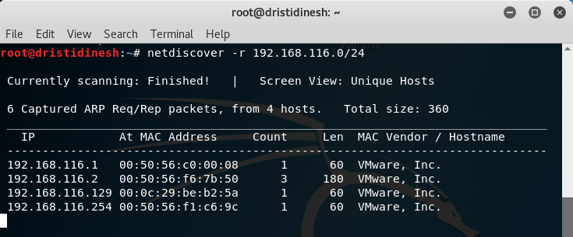  
  
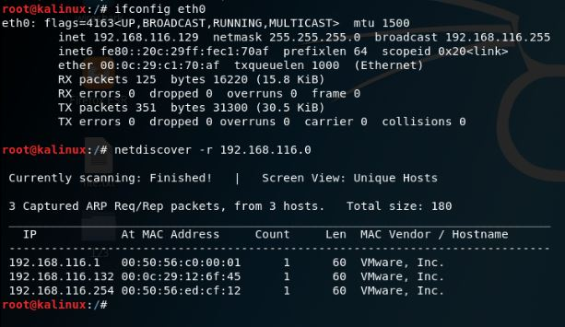

## SCANNING PHASE

In this phase of penetration testing, the team utilized various tools (pre-installed on Kali Linux) to identify possible vulnerabilities through scanning and mapping attack vectors.

* **Nmap** - This is a tool that discovers hosts and services on a network by sending packets and analysing the responses. Nmap provides a number of features for probing computer networks, including host discovery and service and operating system detection.  
    
  This tool allowed us to probe at the Metasploitable machine’s ports and discover a number of services and the ports they are listening on.

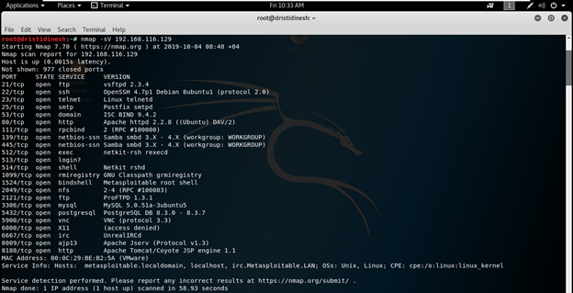

* **DIRB** is a Web Content Scanner. It looks for existing (and/or hidden) Web Objects. It basically works by launching a dictionary based attack against a web server and analysing the response. It looks for specific web objects that other generic CGI scanners can’t look for.   
  (Source: <https://tools.kali.org/web-applications/dirb>)  
    
  Analysing the result of the tool’s scan, the team inferred that the machine is hosting PHP-HTML based webpages and services such as PhpMyAdmin administration tool and the TWiki web application, as can be seen from the following screenshots:

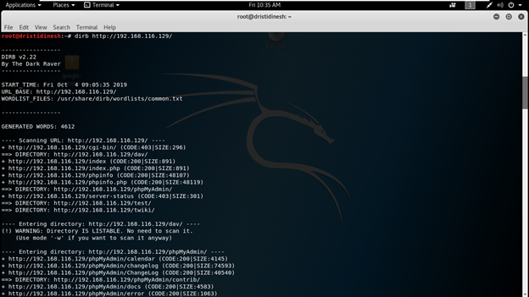



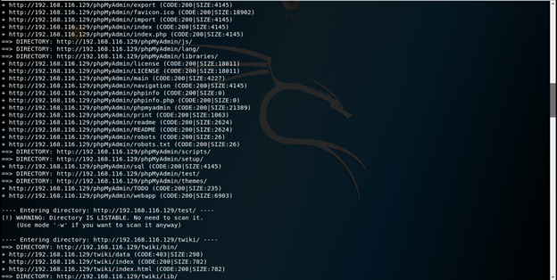

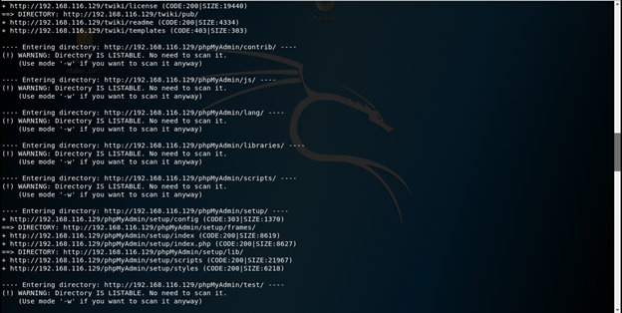

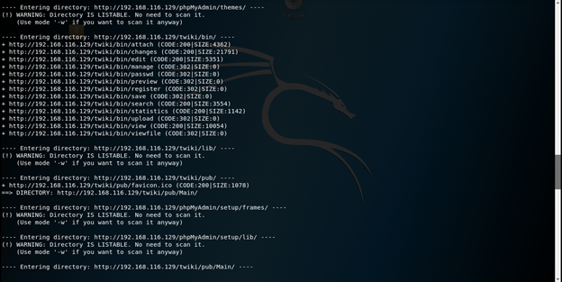

* **Nikto** is an Open Source (GPL) web server scanner which performs comprehensive tests against web servers for multiple items, including over 6700 potentially dangerous files/programs, checks for outdated versions of over 1250 servers, and version specific problems on over 270 servers. It also checks for server configuration items such as the presence of multiple index files, HTTP server options, and will attempt to identify installed web servers and software (Source: <https://tools.kali.org/web-applications/nikto>).

The result of the nikto scan yielded similar information as the DIRB tool, that the machine has PHP installed and interesting information about the application of PHPMyAdmin.

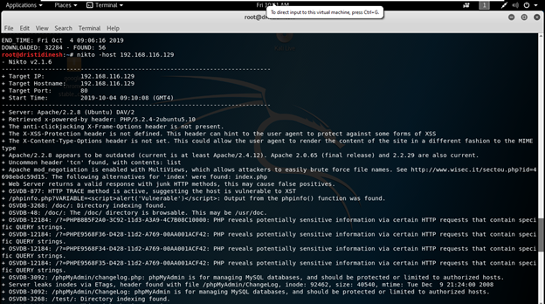

# DETAILED VULNERABILITY FINDINGS

## EXPLOITATION PHASE

### C1 – Samba Version 3.0 Exploit

With the exploitation of certain modules of the file-sharing service Samba and the specific version of Samba running on the host, the team was able to gain root access to the machine. This allowed for a new user to be created on the target.

**Process:**

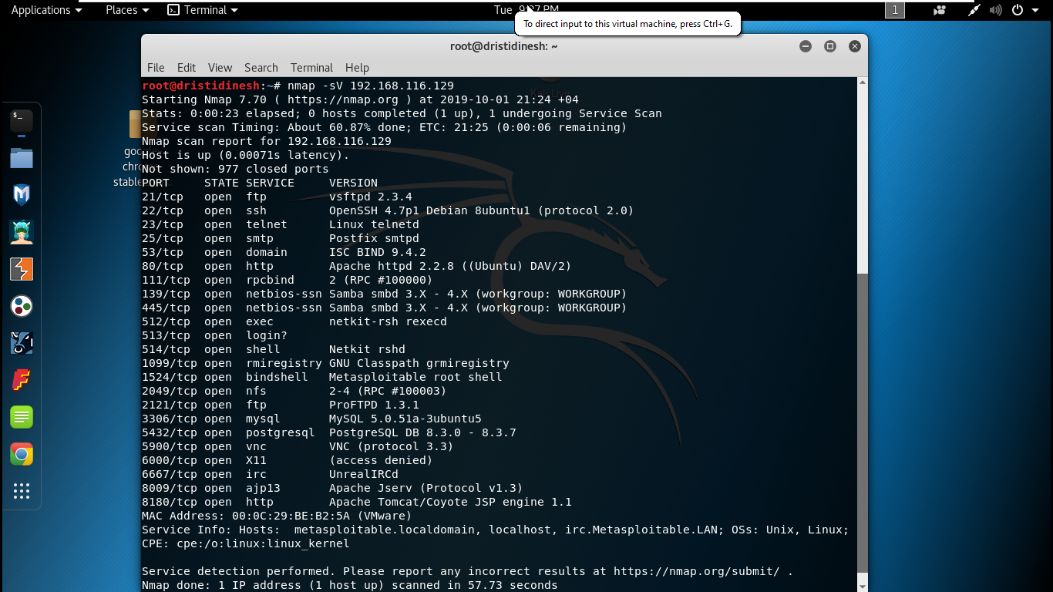It can be seen that a vulnerable version of the Samba service is running on ports 139 and port 445 from this nmap scan.

Upon further exploration through the Metasploit framework console, the team discovered that the version of Samba can be inferred through the following exploit:

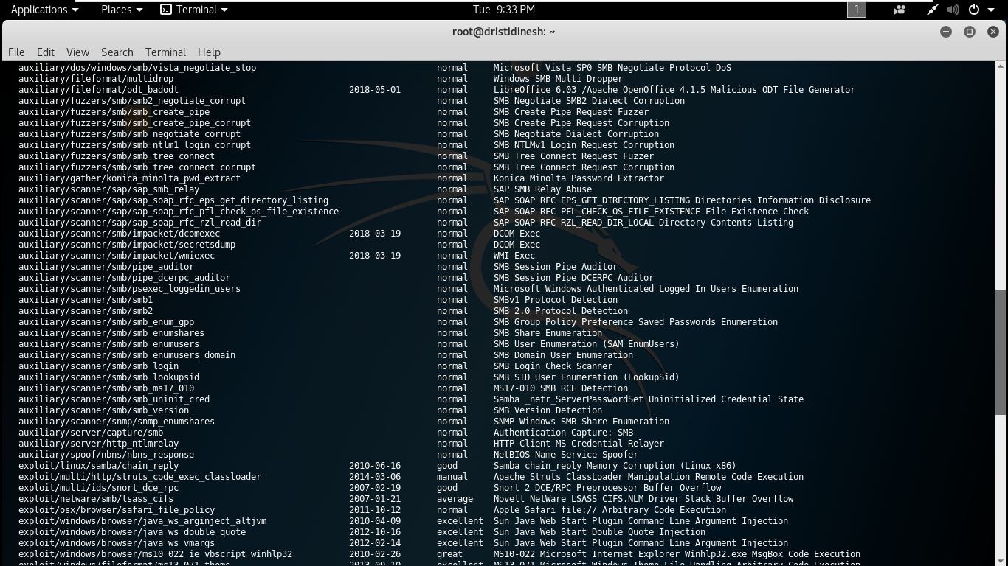

The team then ran the exploit after setting the required options such as RHOSTS (IP of Metasploitable), as can be seen from the following screenshots:

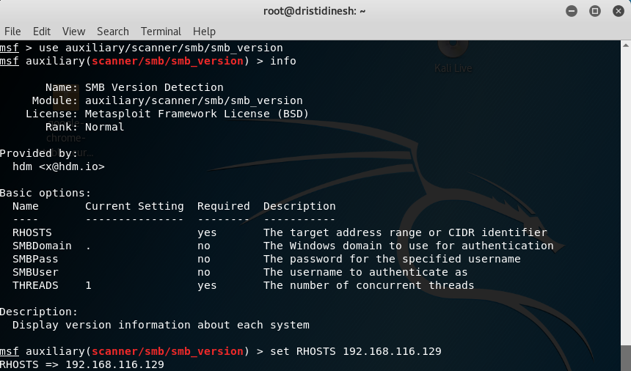

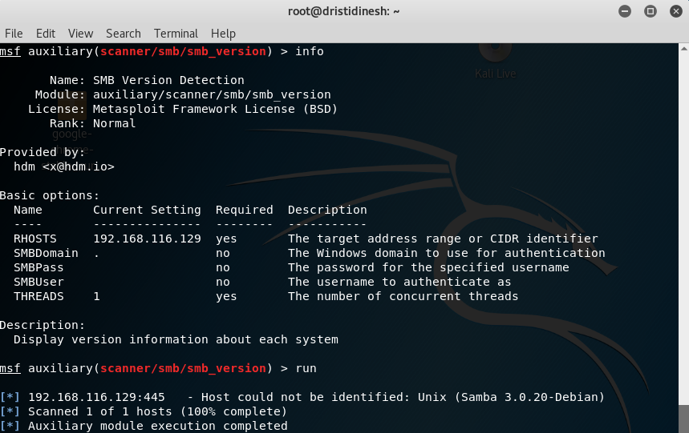

The version of Samba running on the machine (Samba 3.0.20-Debian) is vulnerable to an exploit that allows us to open a shell remotely. The exploit and the options set to run it are as follows:

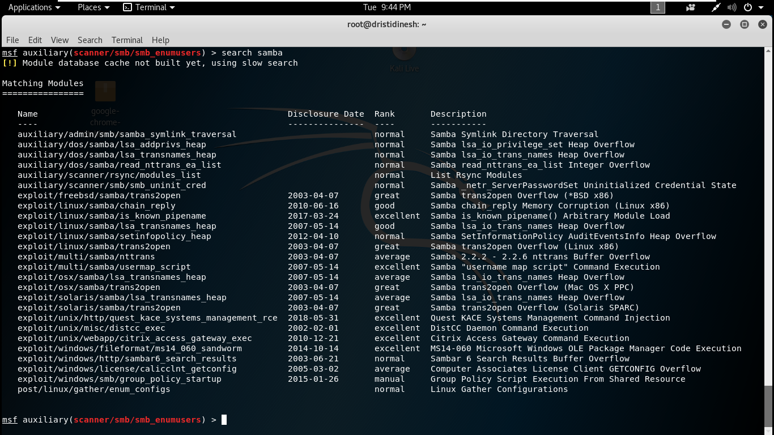

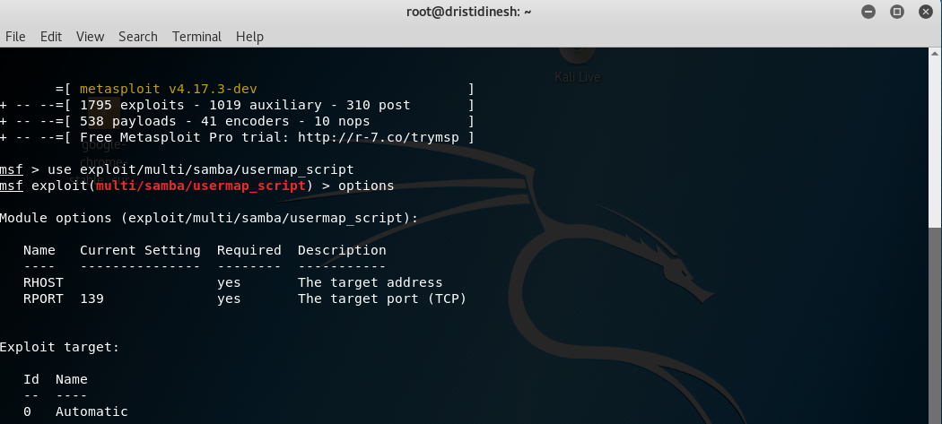

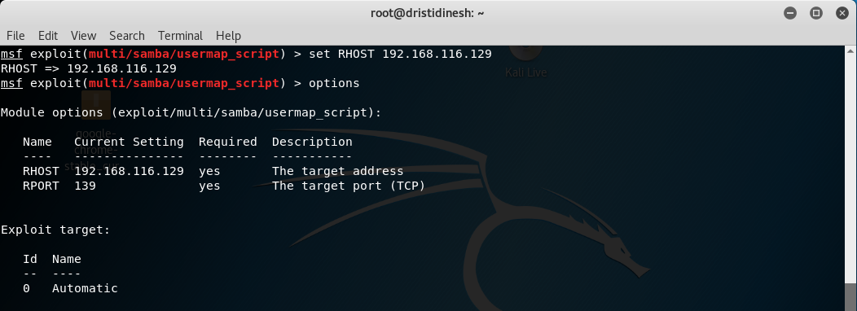

Once the team was logged into the shell as root, the team was able to create a new user into the target machine. Hypothetically, this could allow an attacker to use that new user to go undetected while conducting malicious activity. The process is demonstrated as follows:

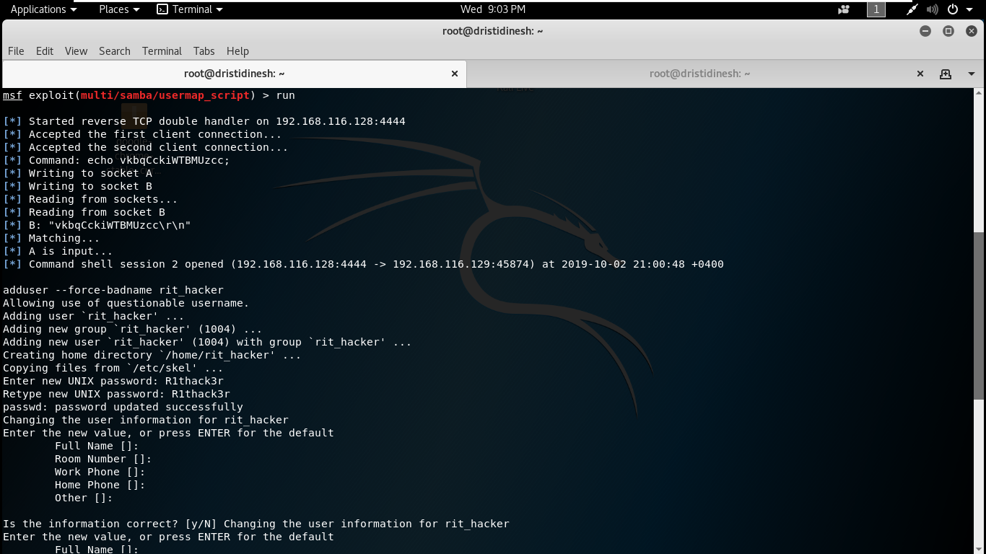

A look at the /etc/shadow file confirms the creation of the new user.

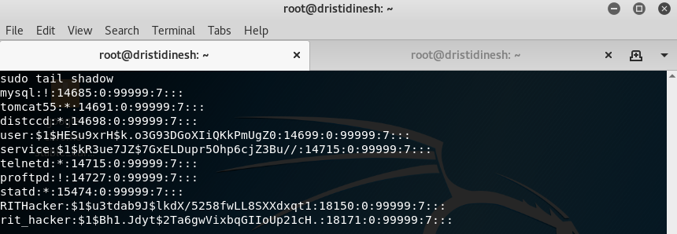  
  
**Risk Rating:** CRITICAL

**Remediation:**  
  
Install a newer, patched version of Samba that is more secure and less vulnerable.

### C2 – vsftpd 2.3.4 Exploit

This exploit allows the user to gain access to the shell via a backdoor that was made in 2011 and removed shortly thereafter.

**Process:**

1. Login to the msf console.
2. Find your IP address.
3. Obtain the IP address from the Metasploitable machine or whatever system you are exploiting.
4. Next, the command nmap -sS -sV -O (Metasploitable 2 IP address) provides you with everything you can know about the ports on that particular system.
5. Enter “search vsftp.”
6. Enter “use exploit/unix/ftp/vsftpd_234_backdoor” to run the exploit.
7. Enter “show options.”
8. Enter “set RHOST”
9. Finally enter “exploit” to run the exploit.  
     
   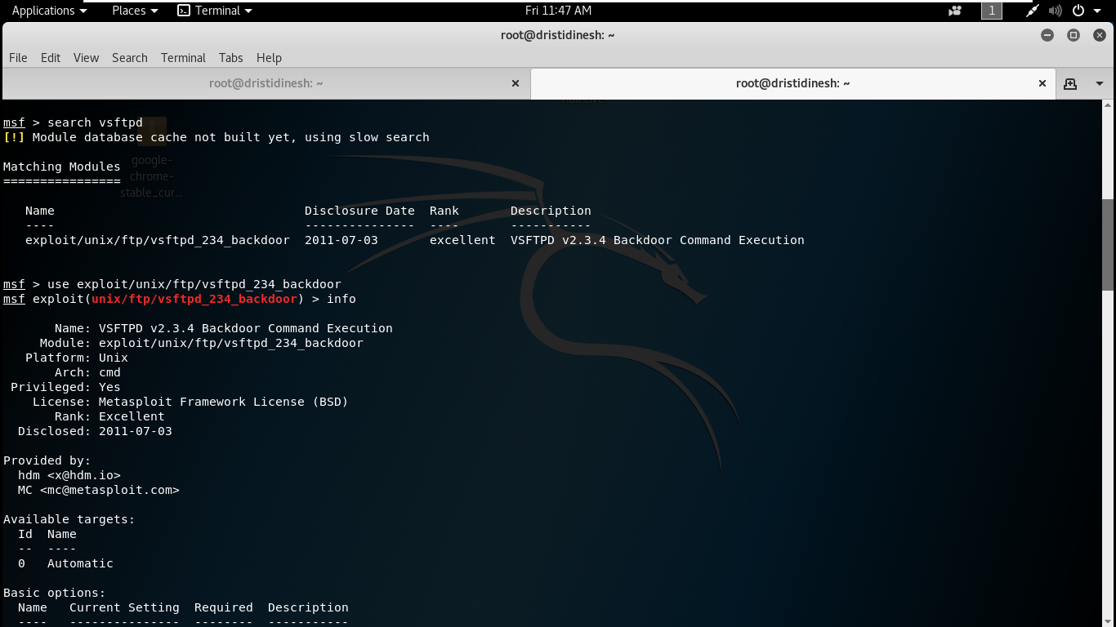

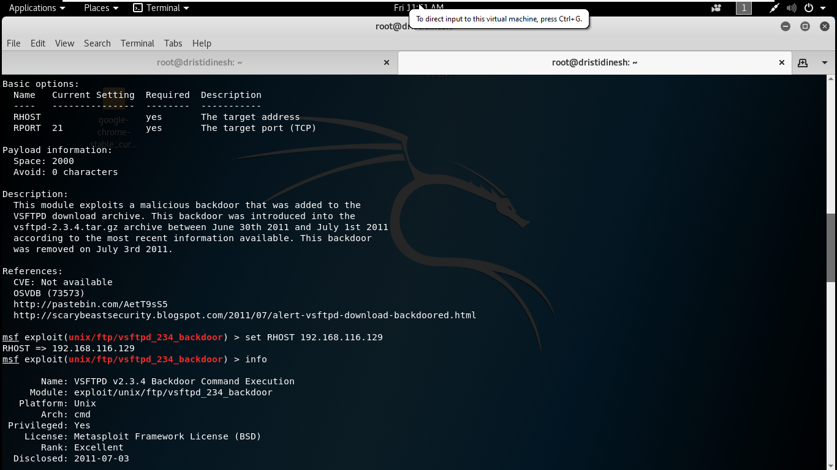

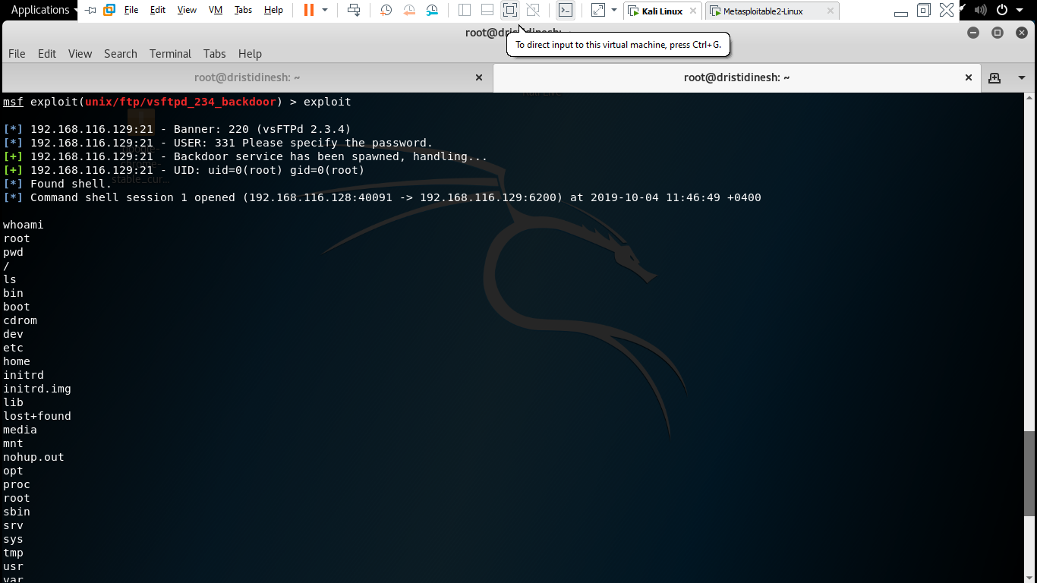

The above screenshots demonstrate the process for this particular exploit.  
**Risk Rating:** CRITICAL  
  
**Remediation:**

Install patched newer version of vsftpd and consider uninstalling either vsftpd or ProFTPD due to redundancy.

### C3 – Bind Root Shell on Port 1524

The nmap scan revealed to us that the Metasploitable root shell is bound to port 1524.

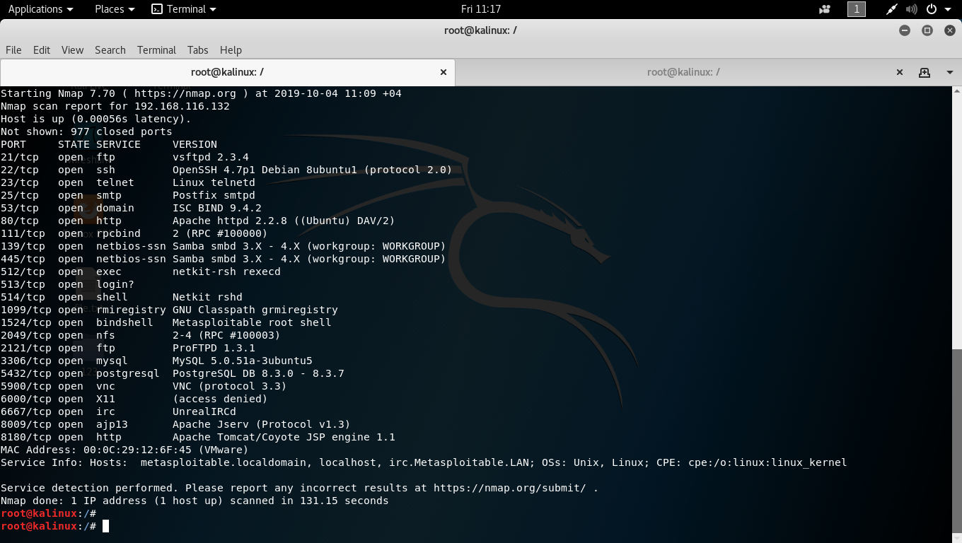

**netcat** is a computer networking utility for reading from and writing to network connections using TCP or UDP. The command is designed to be a dependable back-end that can be used directly or easily driven by other programs and scripts (Source: <https://en.wikipedia.org/wiki/Netcat> ).  
  
Using this tool, the team connected to port 1524 on the target machine and was able to login as root and gain access.  
  
The screenshot demonstrating this is on the next page.

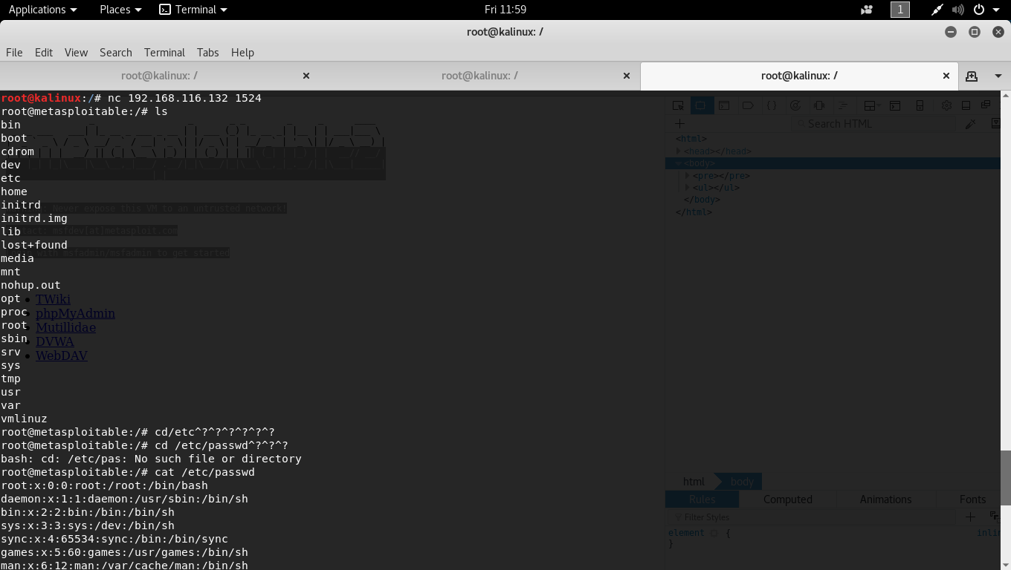

**Risk Rating:** CRITICAL

**Remediation:**Never bind root shell execution to any port that can easily be connected to remotely.

H1 – Private Credentials Visible on Home Page

The credentials of the user **msfadmin** are displayed publically on the machine’s home webpage.

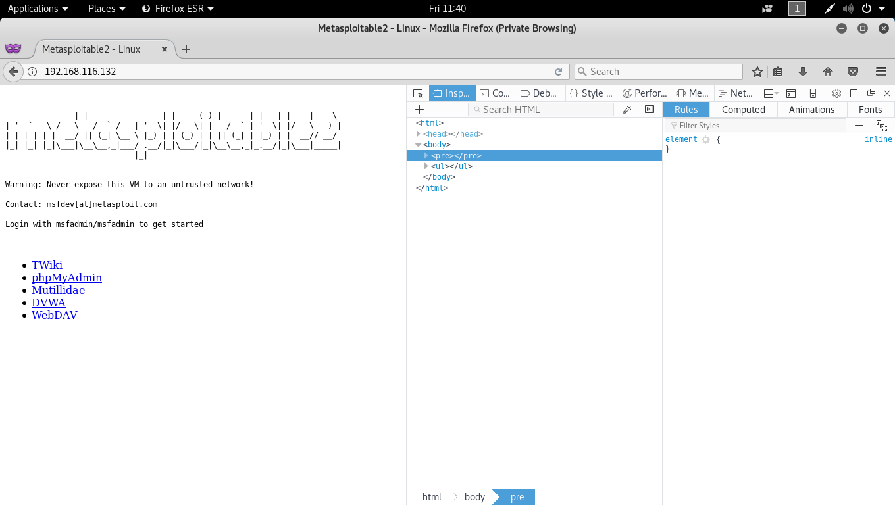

**Risk Rating:** HIGH

**Remediation:**Never display credentials of any service publically. Removing this from the webpage will prevent the risk associated with the following vulnerability (H2 – OpenSSH 4.7 Exploit) and other possible vulnerabilities in services with these valid user credentials.

H2 – OpenSSH 4.7 Exploit

With the help of the credentials acquired in vulnerability H1, one can easily log into OpenSSH using those vaild credentials. Apart from this, the fact that the nmap scan was able to detect OpenSSH is in itself a vulnerability.

The following screenshots show this exploit, as well as displays that the user credentials found have super user privileges set to “**all”.** Browsing the directories of the machine also gives us further information about the user.

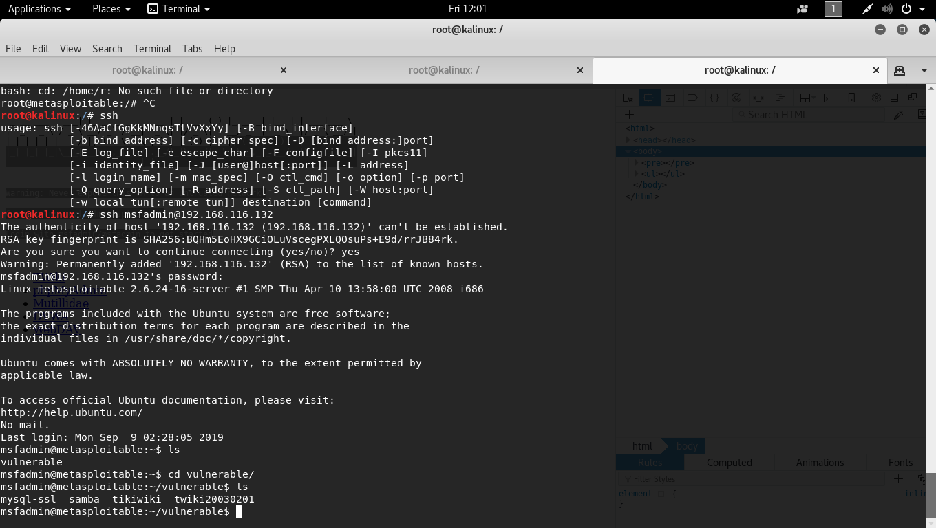

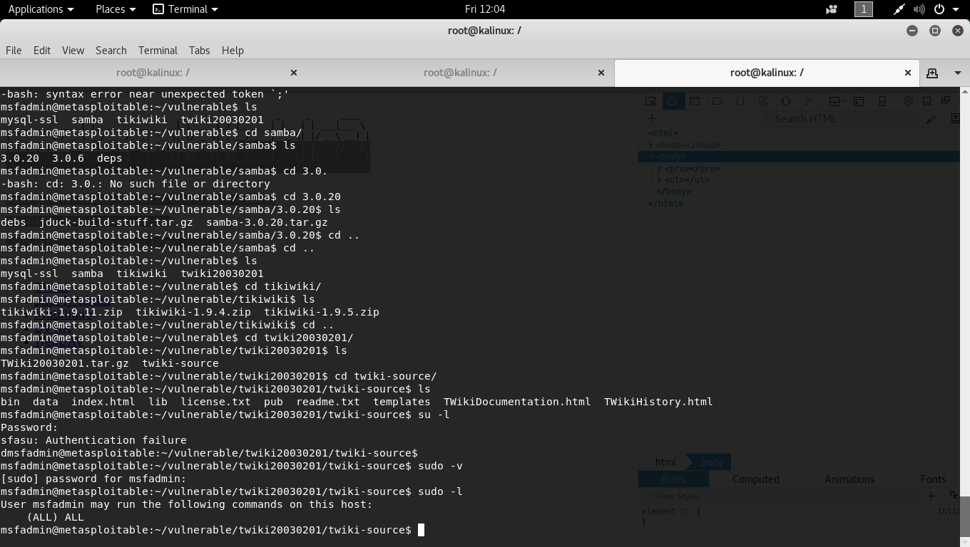

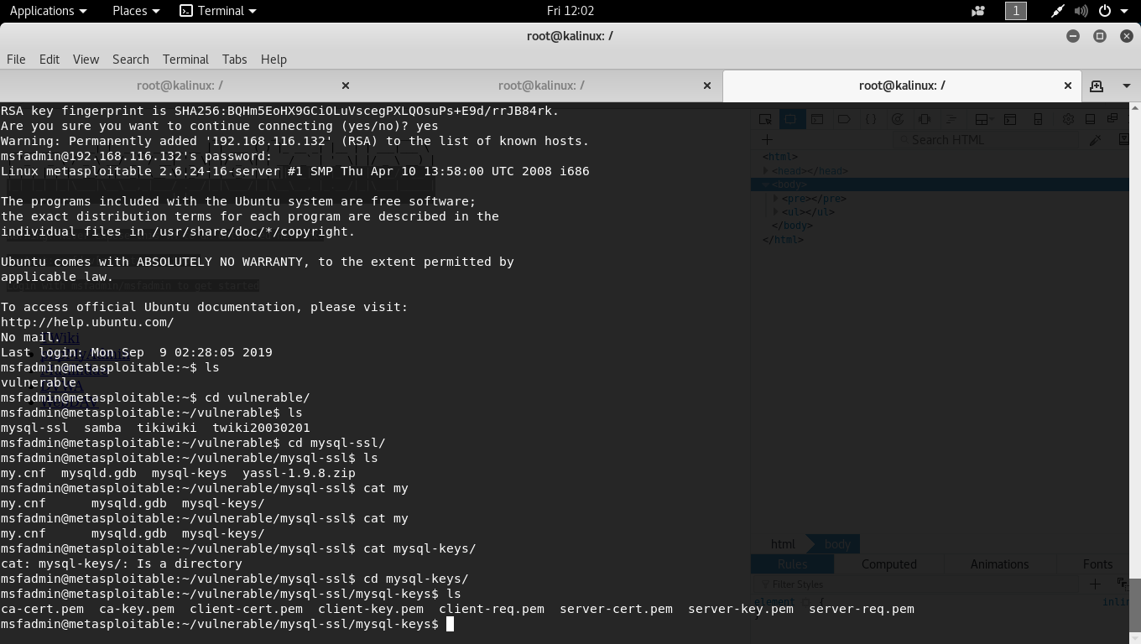Sensitive data was found in the form of mysql login keys, as can be seen above. Pursuing this further would allow an attacker to do much more damage in this situation.

**Risk Rating:** HIGH

**Remediation:**Never display credentials of any service publically. Removing this from the webpage will prevent the risk associated with the following vulnerability (H2 – OpenSSH 4.7 Exploit) and other possible vulnerabilities in services with these valid user credentials. Consider using a more secure version of OpenSSH as well.

H3 – ProFTPD 1.3.1 Exploit

With the help of the credentials acquired in vulnerability H1, the team was able to log in to ProFTPD as well. One can easily transfer files with these credentials. Again, the fact that the nmap scan was able to detect ProFTPD is in itself a vulnerability.

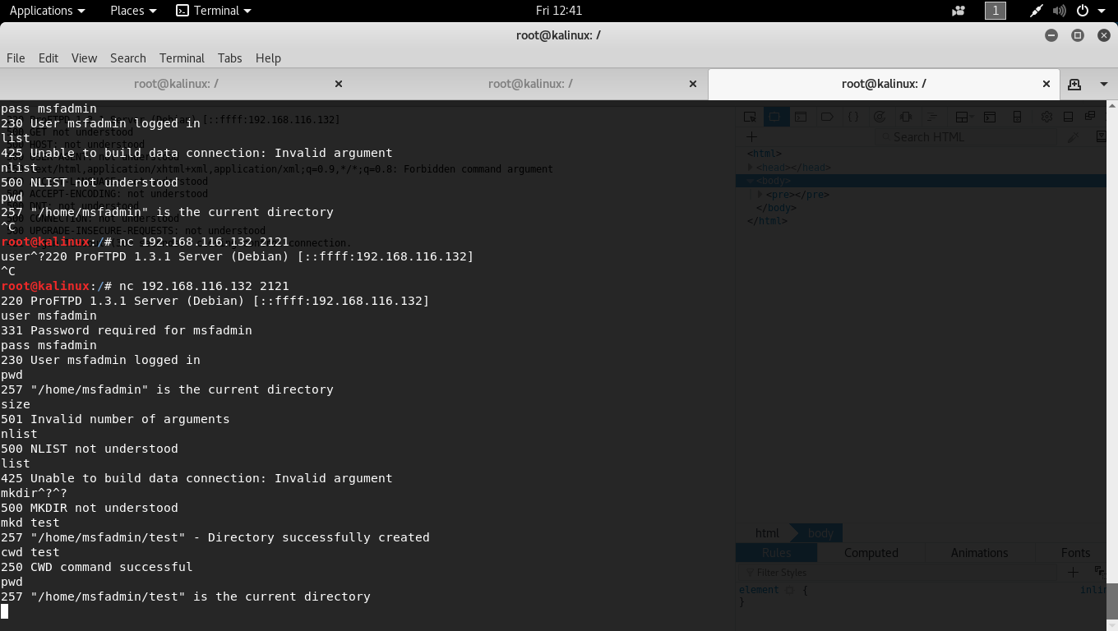

**Risk Rating:** HIGH

**Remediation:**Do not make valid credentials visible publically. Install a newer, patched version of ProFTPD as well, since this version is not the latest.  
Consider uninstalling either vsftpd or ProFTPD due to redundancy.

M1 – Apache Tomcat JSP Engine 1.1 Exploit

The nmap scan shows the service Apache Tomcat JSP Engine 1.1 running on port 8180, which happens to be a vulnerable version of Apache Tomcat.  
  
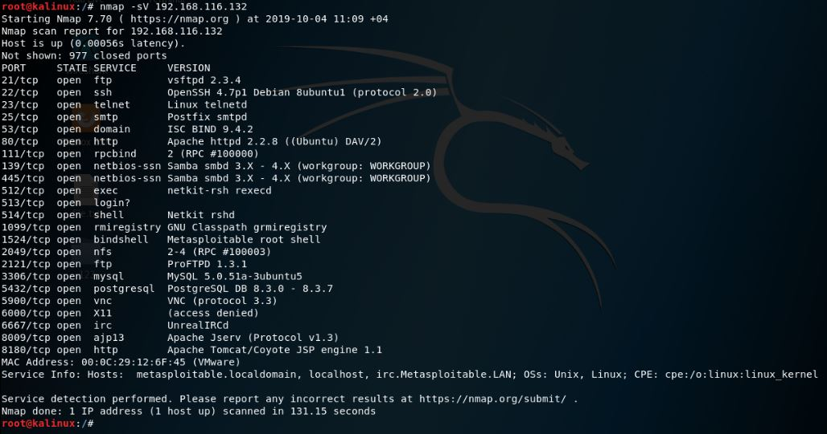  
  
As you can see, going to the webpage on port 8180 of the target machine gives us the landing page of Apache Tomcat, and subsequently requests credentials to continue.  
  
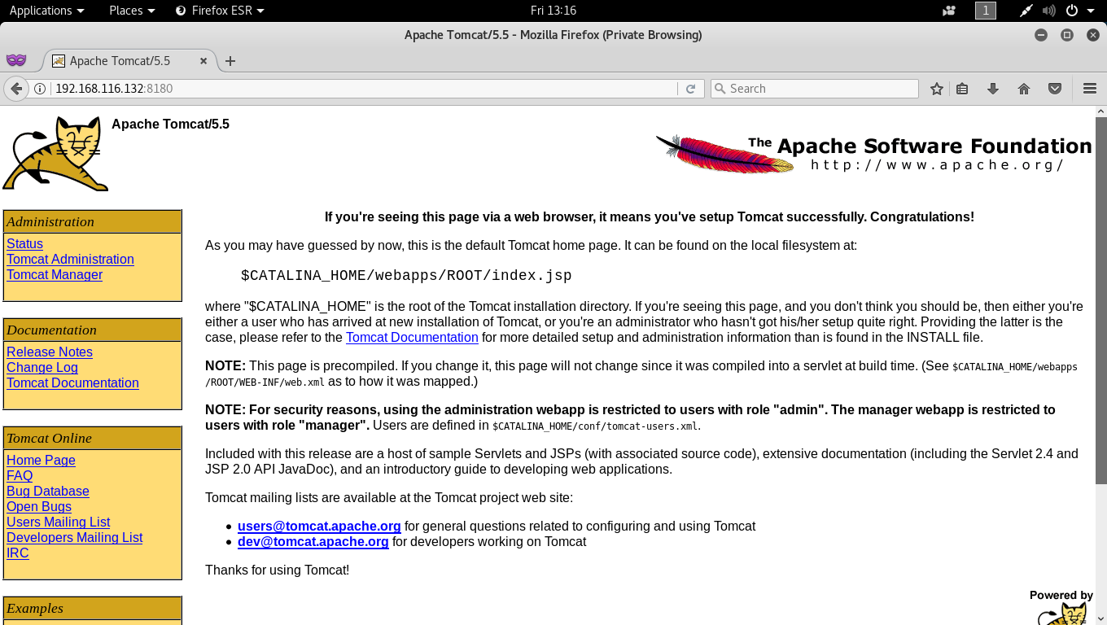

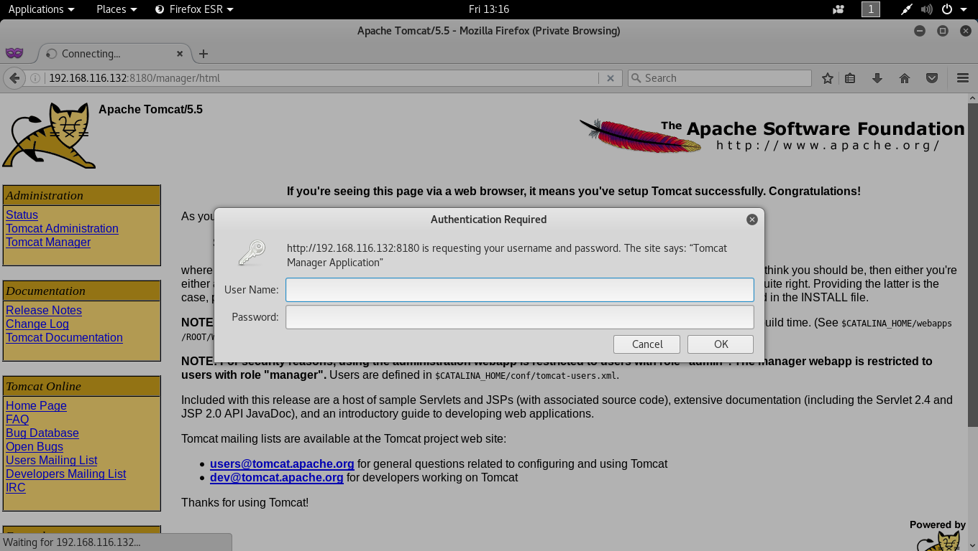  
  
Using the Metasploit framework console, the team found an exploit that allows us to brute force for user login information, shows as follows:  
  
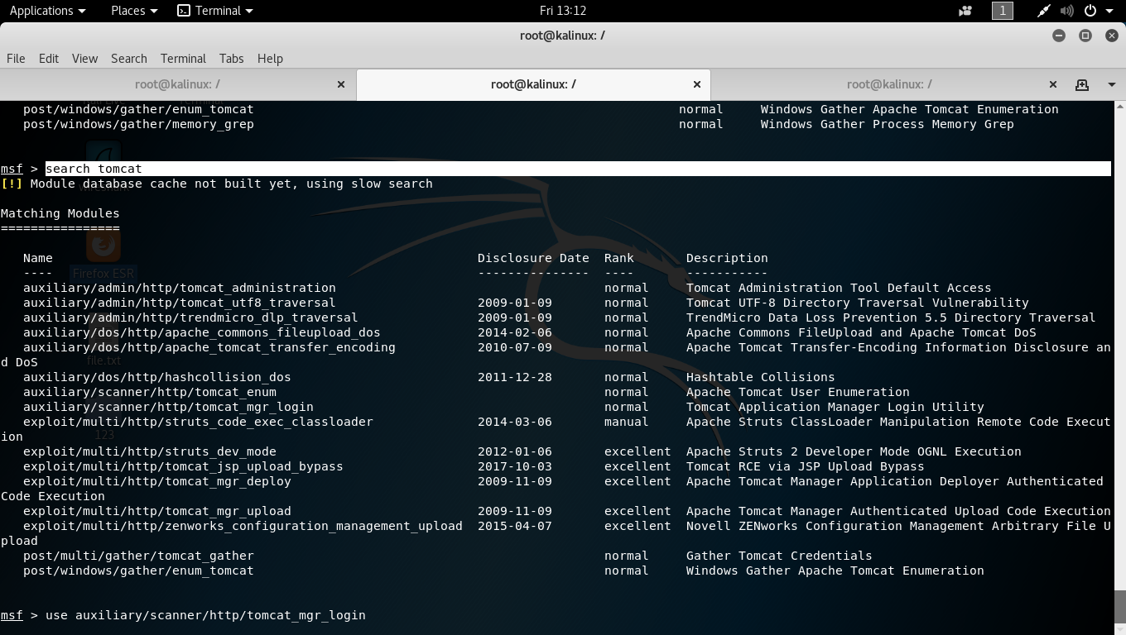

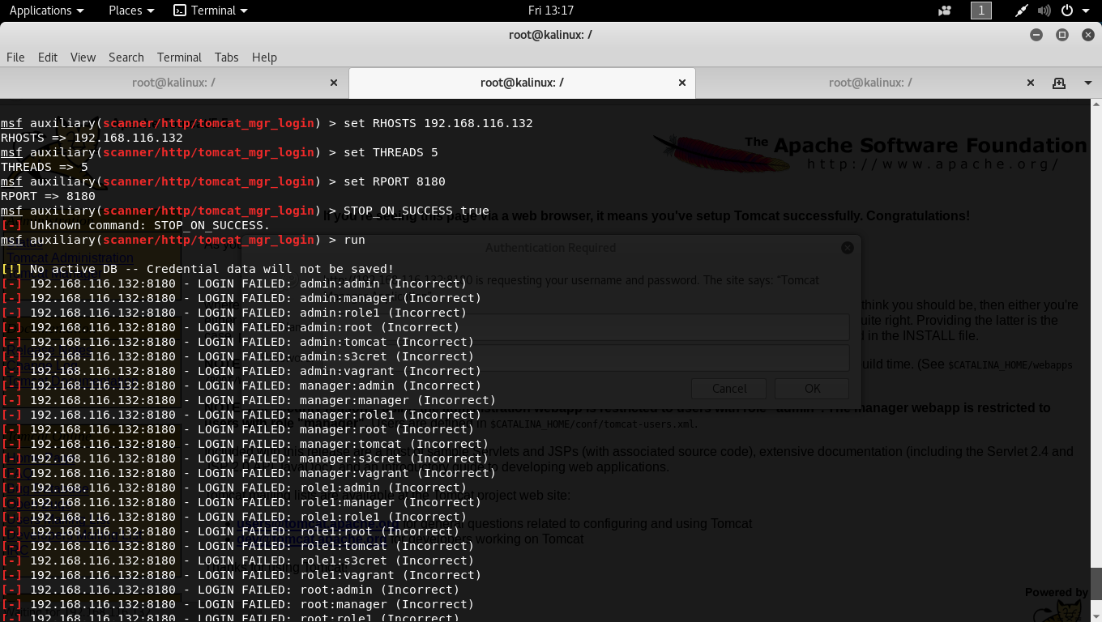

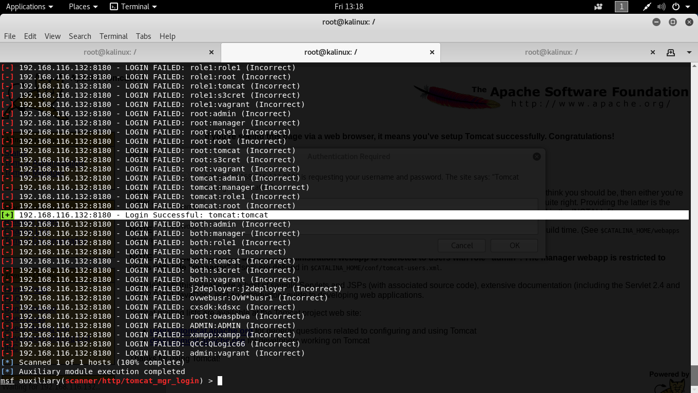

Running the exploit gives us valid credentials (tomcat:tomcat) as seen above, which when put into the site, logs us into the Apache Tomcat as an admin that has the authorization to make various edits to the web application.  
  
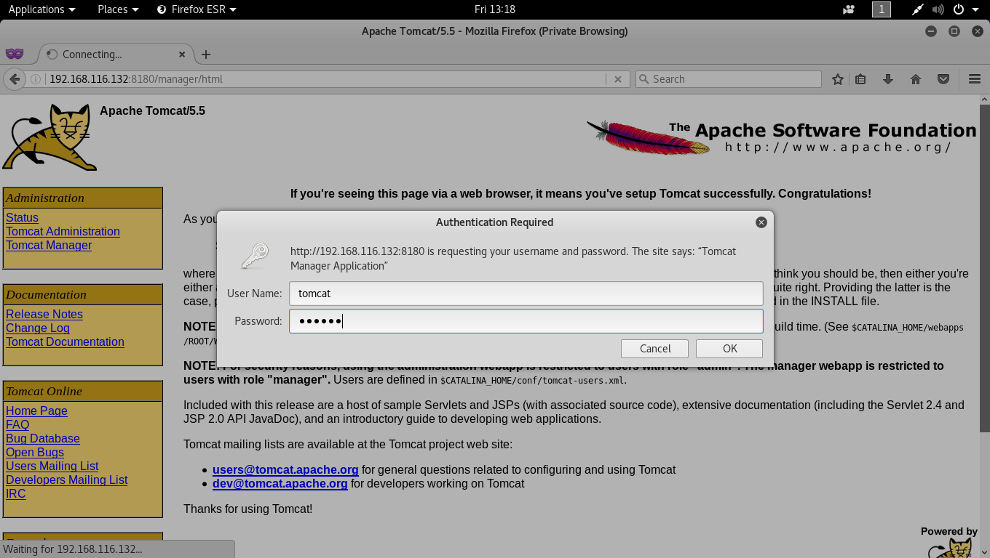  
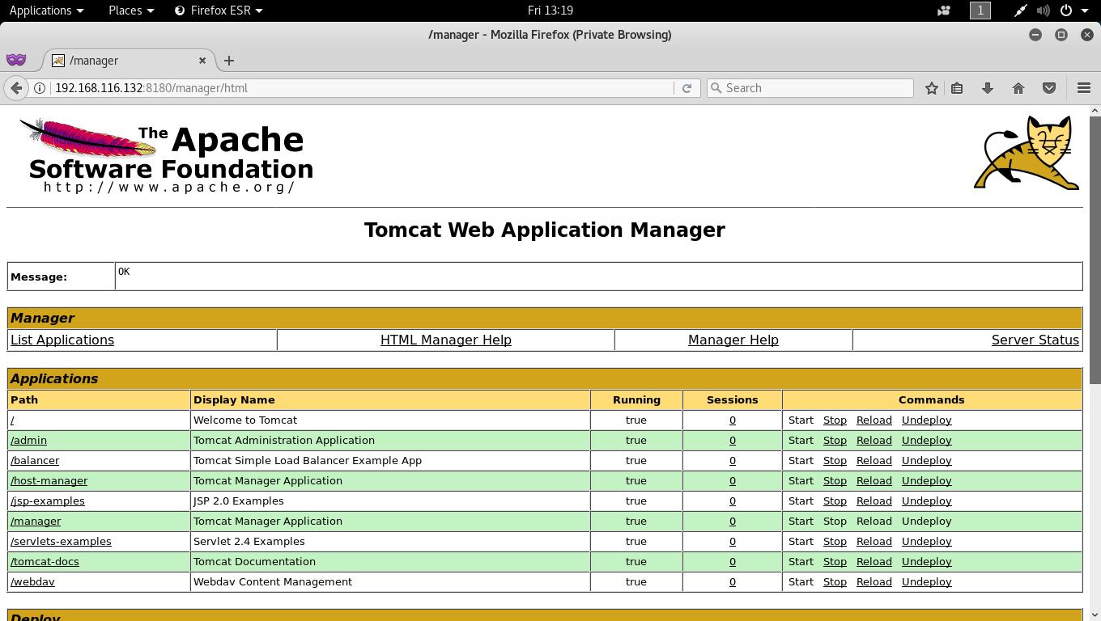  
  
  
**Risk Rating:** MEDIUM

**Remediation:**  
Do not allow credentials that are weak or default credentials that can easily be cracked using brute force. Install the latest, patched version of Apache Tomcat that is less vulnerable to exploits.